# Basic Spring Application with Constructor Injection.

## Aim: Basic Spring Application with Constructor Injection.

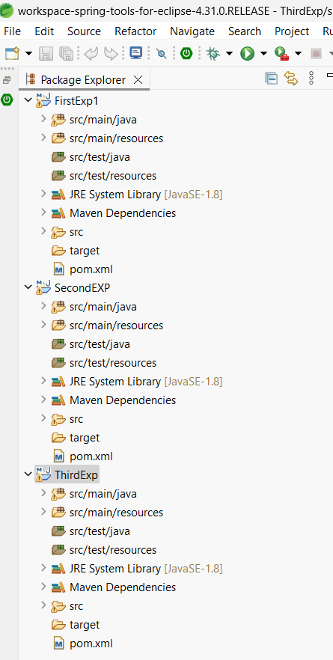

**MainDemo.java:-**

package com.example;

import org.springframework.context.ApplicationContext;

import org.springframework.context.support.ClassPathXmlApplicationContext;

public class MainDemo {

public static void main(String[] args) {

// TODO Auto-generated method stub

ApplicationContext context = new ClassPathXmlApplicationContext("config.xml");

student s = context.getBean("S",student.class); System.out.println(s);

s.Read();

}

}

## Student.java:-

package com.example; public class Student {

int Rno;

String StudentName;

public Student(int rno, String studentName) { super();

Rno = rno;

StudentName = studentName;

}

public Student(String studentName) { super();

StudentName = studentName;

}

"]";

*@Override*

public String toString() {

return "Student [Rno=" + Rno + ", StudentName=" + StudentName +

}

public void Read() {

System.out.println(“This is Employee class method”);

}

}

## Config.xml:-

<?xml version="1.0" encoding="UTF-8"?>

<beans xmlns=["http://www.springframework.org/schema/beans](http://www.springframework.org/schema/beans)" xmlns:xsi=["http://www.w3.org/2001/XMLSchema-instance"](http://www.w3.org/2001/XMLSchema-instance) xsi:schemaLocation=["http://www.springframework.org/schema/beans](http://www.springframework.org/schema/beans) https://[www.springframework.org/schema/beans/spring-beans.xsd](http://www.springframework.org/schema/beans/spring-beans.xsd)">

<bean id="S" class="com.example.student">

<constructor-arg type="int" value="123"></constructor-arg>

<constructor-arg type="String" value="Valli"></constructor-arg>

</bean>

</beans>

## Pom.xml:-

<project xmlns="<http://maven.apache.org/POM/4.0.0>" xmlns:xsi=["http://www.w3.org/2001/XMLSchema-instance"](http://www.w3.org/2001/XMLSchema-instance) xsi:schemaLocation=["http://maven.apache.org/POM/4.0.0](http://maven.apache.org/POM/4.0.0) https://maven.apache.org/xsd/maven-4.0.0.xsd">

<modelVersion>4.0.0</modelVersion>

<groupId>Naveen</groupId>

<artifactId>Second</artifactId>

<version>0.0.1-SNAPSHOT</version>

<dependencies>

<!-- https://mvnrepository.com/artifact/org.springframework/spring-core -->

<dependency>

<groupId>org.springframework</groupId>

<artifactId>spring-core</artifactId>

<version>7.0.0-M7</version>

</dependency>

<!-- https://mvnrepository.com/artifact/org.springframework/spring-context -->

<dependency>

<groupId>org.springframework</groupId>

<artifactId>spring-context</artifactId>

<version>7.0.0-M7</version>

</dependency>

</dependencies>

</project>

# Output :-

# 

1. **Spring Application with Setter Injection.**

## Aim: Spring Application with Setter Injection.

### MainDemo.java:-

package com.programs;

import org.springframework.context.support.ClassPathXmlApplicationContext; import org.springframework.context.ApplicationContext;

public class FinalDemo {

public static void main(String[] args) {

// TODO Auto-generated method stub

ApplicationContext context = new ClassPathXmlApplicationContext("App.xml"); Employee e1= context.getBean("e",Employee.class);

System.***out***.println(e1);

}

}

### Employee.java:-

package com.programs; public class Employee {

int Eno; String Ename;

public int getEno() {

return Eno;

}

public void setEno(int eno) { Eno = eno;

}

public String getEname() { return Ename;

}

public void setEname(String ename) { Ename = ename;

}

*@Override*

public String toString() {

return "Employee [Eno=" + Eno + ", Ename=" + Ename + "]";

}

}

### App.xml (config.xml file):-

<?xml version="1.0" encoding="UTF-8"?>

<beans xmlns=["http://www.springframework.org/schema/beans](http://www.springframework.org/schema/beans)" xmlns:xsi=["http://www.w3.org/2001/XMLSchema-instance"](http://www.w3.org/2001/XMLSchema-instance) xsi:schemaLocation=["http://www.springframework.org/schema/beans](http://www.springframework.org/schema/beans) https://[www.springframework.org/schema/beans/spring-beans.xsd](http://www.springframework.org/schema/beans/spring-beans.xsd)">

<bean id="e" class="com.programs.Employee">

<property name="Eno" value="987"></property>

<property name="Ename" value="Valli"></property>

</bean>

</beans>

### Pom.xml:-

<project xmlns="<http://maven.apache.org/POM/4.0.0>" xmlns:xsi=["http://www.w3.org/2001/XMLSchema-instance"](http://www.w3.org/2001/XMLSchema-instance) xsi:schemaLocation=["http://maven.apache.org/POM/4.0.0](http://maven.apache.org/POM/4.0.0) https://maven.apache.org/xsd/maven-4.0.0.xsd">

<modelVersion>4.0.0</modelVersion>

<groupId>hii</groupId>

<artifactId>FirstLab</artifactId>

<version>0.0.1-SNAPSHOT</version>

<dependencies>

<!-- https://mvnrepository.com/artifact/org.springframework/spring-core -->

<dependency>

<groupId>org.springframework</groupId>

<artifactId>spring-core</artifactId>

<version>6.2.9</version>

</dependency>

<!-- https://mvnrepository.com/artifact/org.springframework/spring-context -->

<dependency>

<groupId>org.springframework</groupId>

<artifactId>spring-context</artifactId>

<version>6.2.9</version>

</dependency>

</dependencies>

</project>

**OUTPUT :-**

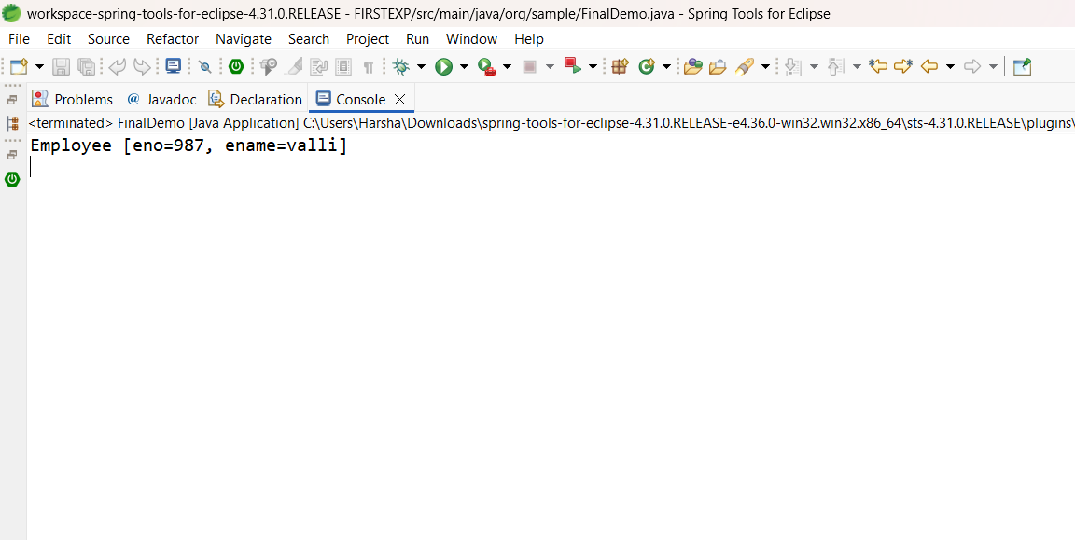

# Spring Auto Scanning Example.

## Aim: Spring Auto Scanning Example.

### FinalDemo.java:-

package org.sample;

import org.springframework.context.ApplicationContext;

import org.springframework.context.support.ClassPathXmlApplicationContext; public class FinalDemo {

public static void main(String[] args) {

// TODO Auto-generated method stub ApplicationContext context=new

ClassPathXmlApplicationContext("app.xml");

Employee e1 = context.getBean("e",Employee.class); System.*out*.println(e1);

e1.read();

}

}

### FirstStudent.java:-

package com.example;

import org.springframework.stereotype.Component; @Component

public class FirstStudent { @Override

public String toString() {

return "My name is Harsha I am studying MCA- II ";

}

}

### SecondStudent.java:-

package com.example;

import org.springframework.beans.factory.annotation.Autowired; import org.springframework.stereotype.Component; @Component

public class SecondStudent { @Autowired FirstStudent f; @Override

public String toString() {

return "My name is Valli, I am studying MCA at Aditya University" +f;

}

}

### Config.xml:-

<beans xmlns=["http://www.springframework.org/schema/beans](http://www.springframework.org/schema/beans)" xmlns:xsi=["http://www.w3.org/2001/XMLSchema-instance"](http://www.w3.org/2001/XMLSchema-instance) xmlns:context="<http://www.springframework.org/schema/context>" xsi:schemaLocation=["http://www.springframework.org/schema/beans](http://www.springframework.org/schema/beans) <http://www.springframework.org/schema/beans/spring-beans-2.5.xsd> <http://www.springframework.org/schema/context> <http://www.springframework.org/schema/context/spring-context-2.5.xsd>">

<context:component-scan base- package="com.example"></context:component-scan>

</beans>

### Pom.xml:-

<project xmlns="<http://maven.apache.org/POM/4.0.0>" xmlns:xsi=["http://www.w3.org/2001/XMLSchema-instance"](http://www.w3.org/2001/XMLSchema-instance) xsi:schemaLocation=["http://maven.apache.org/POM/4.0.0](http://maven.apache.org/POM/4.0.0) https://maven.apache.org/xsd/maven-4.0.0.xsd">

<modelVersion>4.0.0</modelVersion>

<groupId>NK</groupId>

<artifactId>ThirdEx</artifactId>

<version>0.0.1-SNAPSHOT</version>

<dependencies>

<!-- https://mvnrepository.com/artifact/org.springframework/spring-core -->

<dependency>

<groupId>org.springframework</groupId>

<artifactId>spring-core</artifactId>

<version>7.0.0-M7</version>

</dependency>

<!-- https://mvnrepository.com/artifact/org.springframework/spring-context -->

<dependency>

<groupId>org.springframework</groupId>

<artifactId>spring-context</artifactId>

<version>7.0.0-M7</version>

</dependency>

</dependencies>

</project>

**OUTPUT :-**

